

# **Mjlsi System Requirements**

Wireframes

# Contents

**Mjlsi System Requirements** **1**

**Contents** **2**

**Project Overview** **3**

**Accessing the Portal** **3**

**Request for License** **4**

**Organization Profile User Guide** **5**

Accounts 5

Roles 6

Role Listing 6

Add a New Meeting Access Role 7

Committees 8

User Groups Listing 8

Add a New User Group 9

Permissions 10

**Mjlsi Admin User Guide** **11**

Manage Accounts 11

Manage Roles 11

Manage Organizations 12

Manage Licenses 12

# 

# Project Overview

The purpose of the project is to develop a system to create and manage companies meetings. Especially the board meeting that is used by directors and executives. It gives you complete control over the entire meeting process from pre-meeting preparation to post-meeting document distribution.

# Accessing the Portal

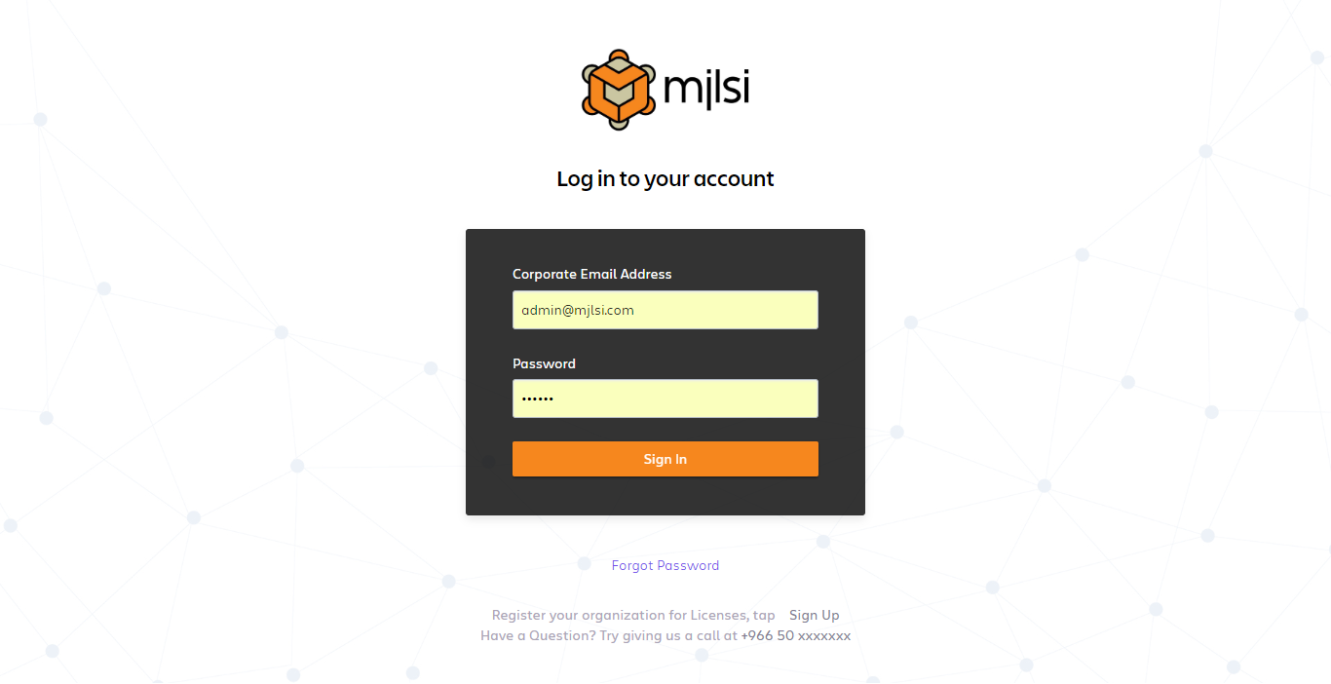

# Forgot Password

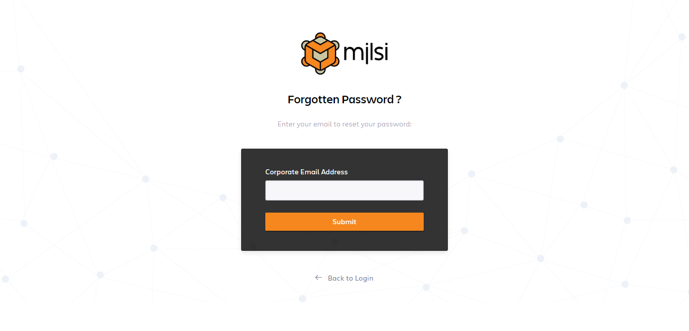

# Request for License

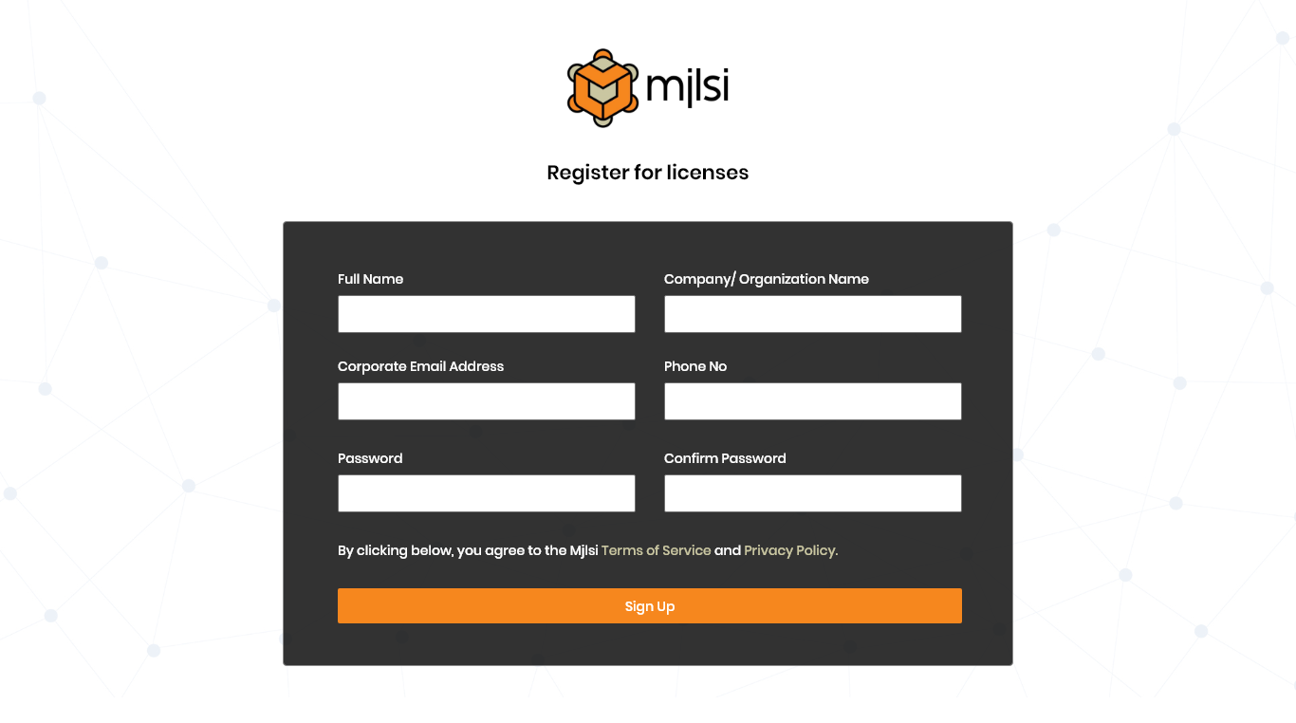

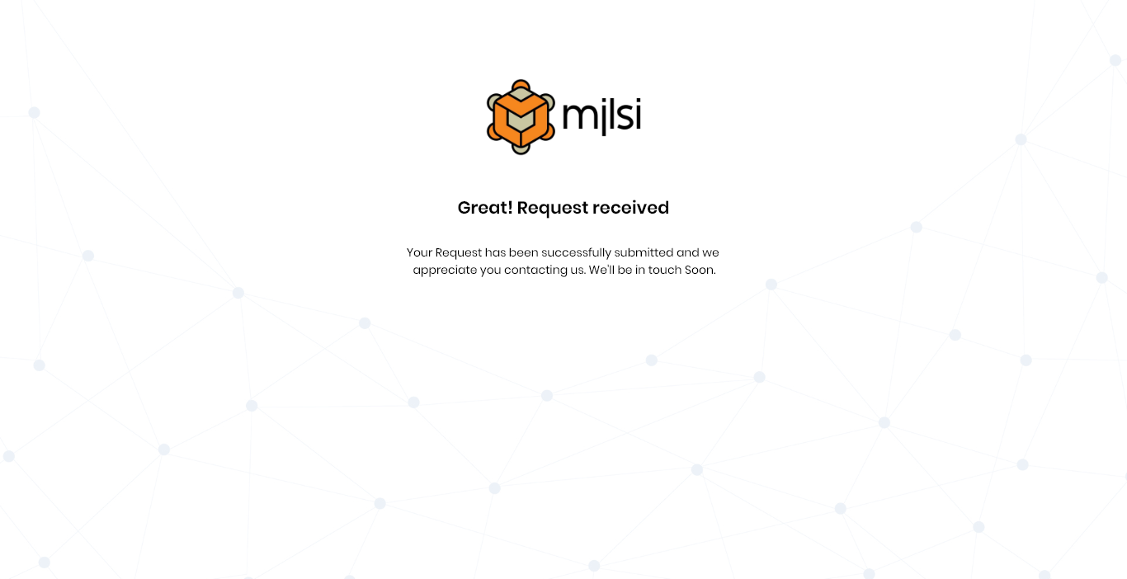

# **Mjlsi Admin**

## Manage Licenses

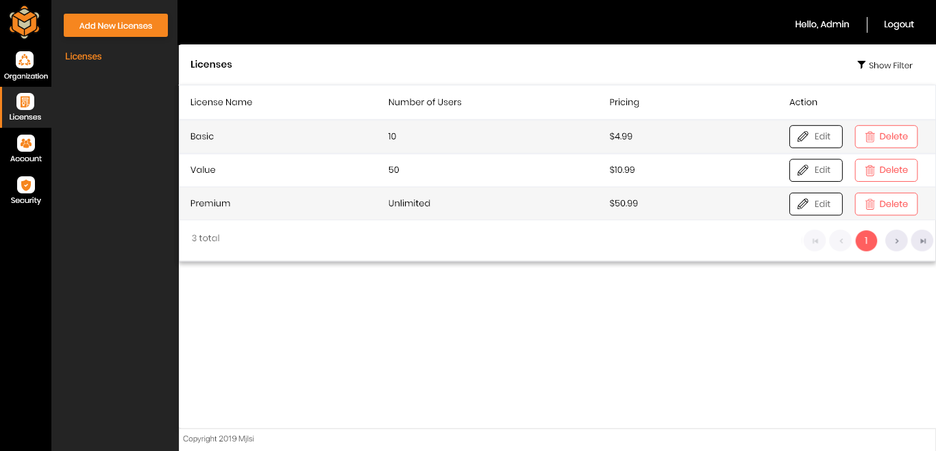

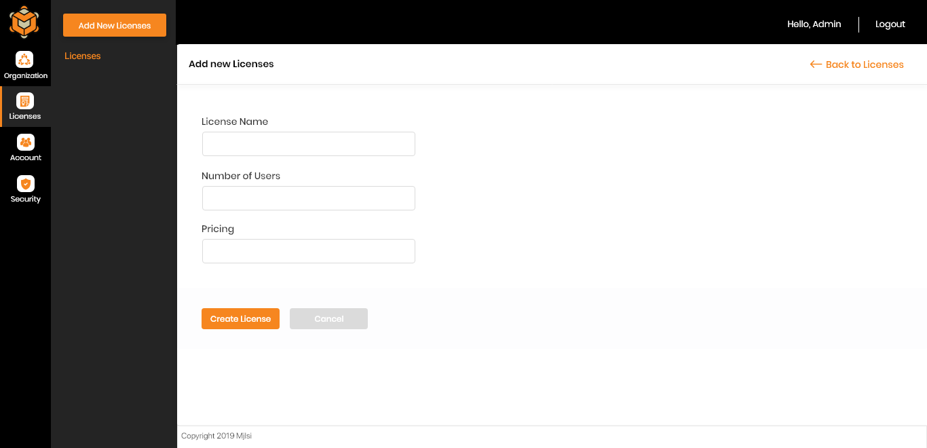

## Manage Organizations

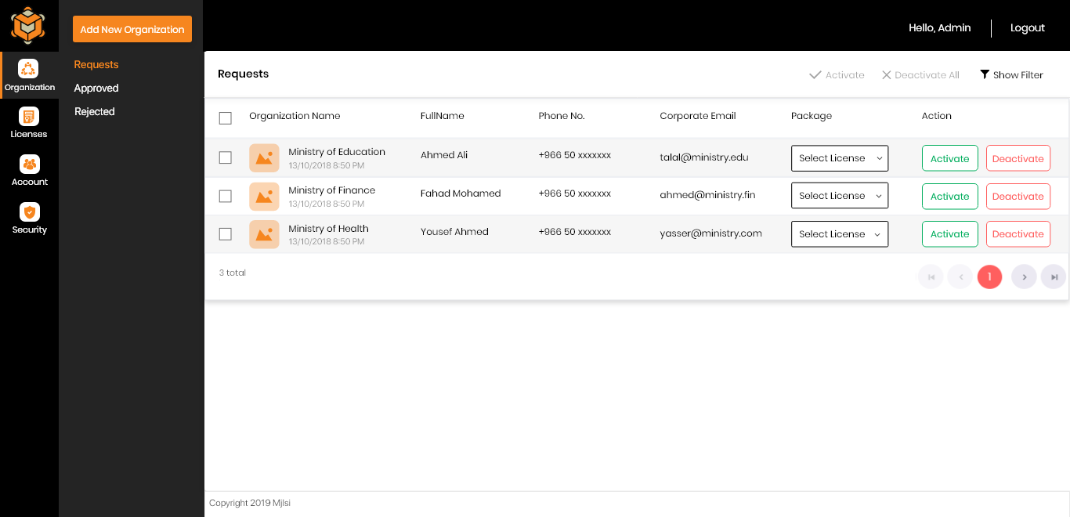

## Manage Accounts

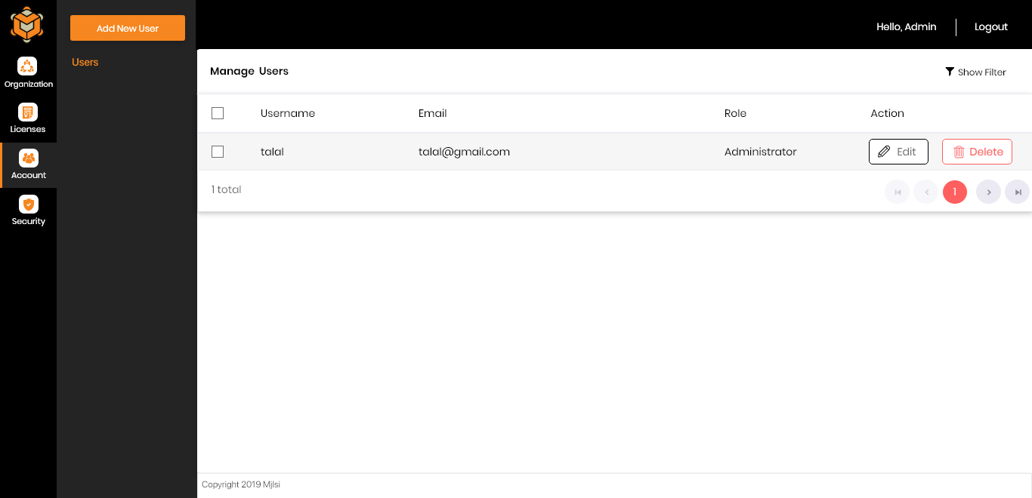

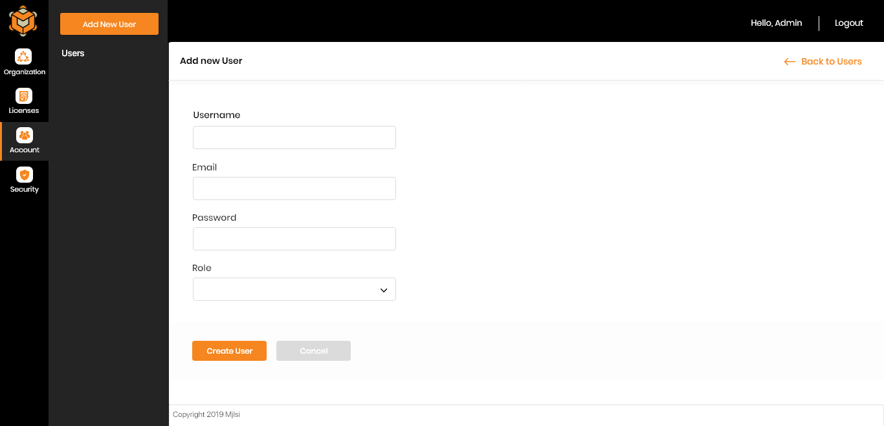

## Security

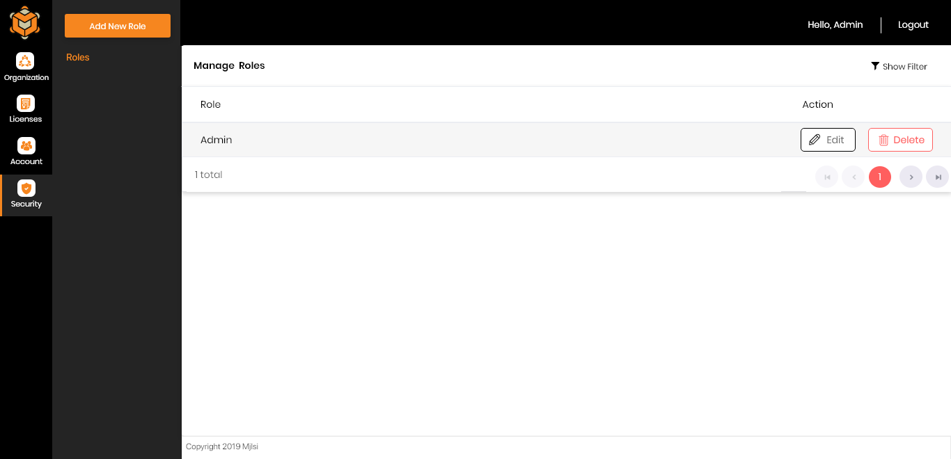

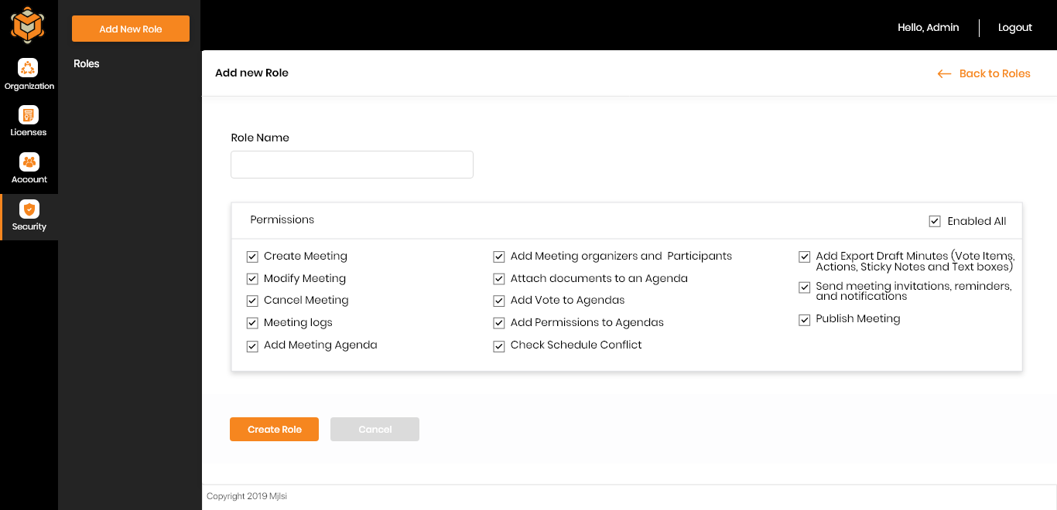

# **Organization Profile**

## Roles

In an Anywhere Pad meeting, participants can have one of the following Meeting Roles: Admin, Secretary, and Board members. These apply to what a user can do in relation to a meeting (before, during, and after). Meeting roles are assigned in the Meetings screen of the portal.

### Role Listing

Meeting access roles are the character or responsibility of a participant in a particular meeting; roles can be: Admin, Secretary, and Board members, etc.

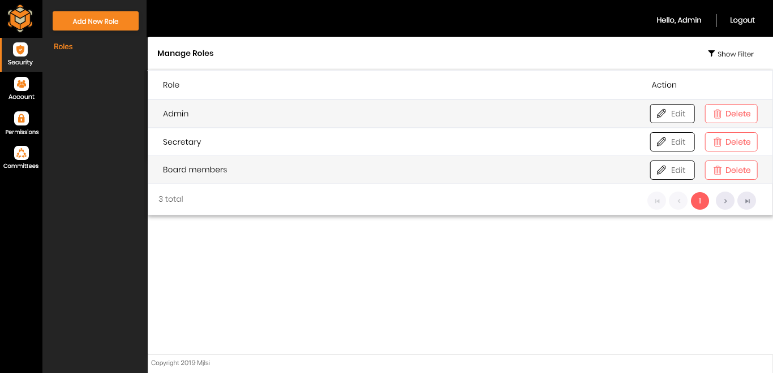

### Add a New Meeting Access Role

The admin user can create new meeting roles to correspond to real-life ranks or positions in an organization. In every meeting, meeting access roles can be viewed, set, or customised by the admin user for each member

1. Click System Admin.

2. Go to Meeting Roles tab.

3. Click Add New Role.

4. Enter the name of the new role. Specify what the role can do in a meeting by marking the corresponding checkboxes of function rights listed.

5. Click Save when done.

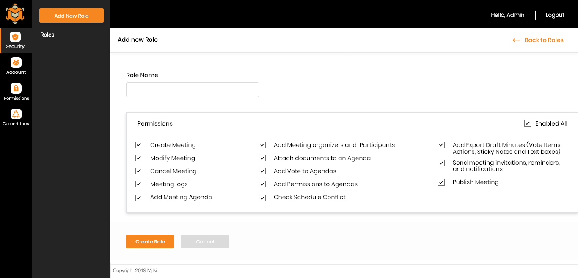

## Accounts

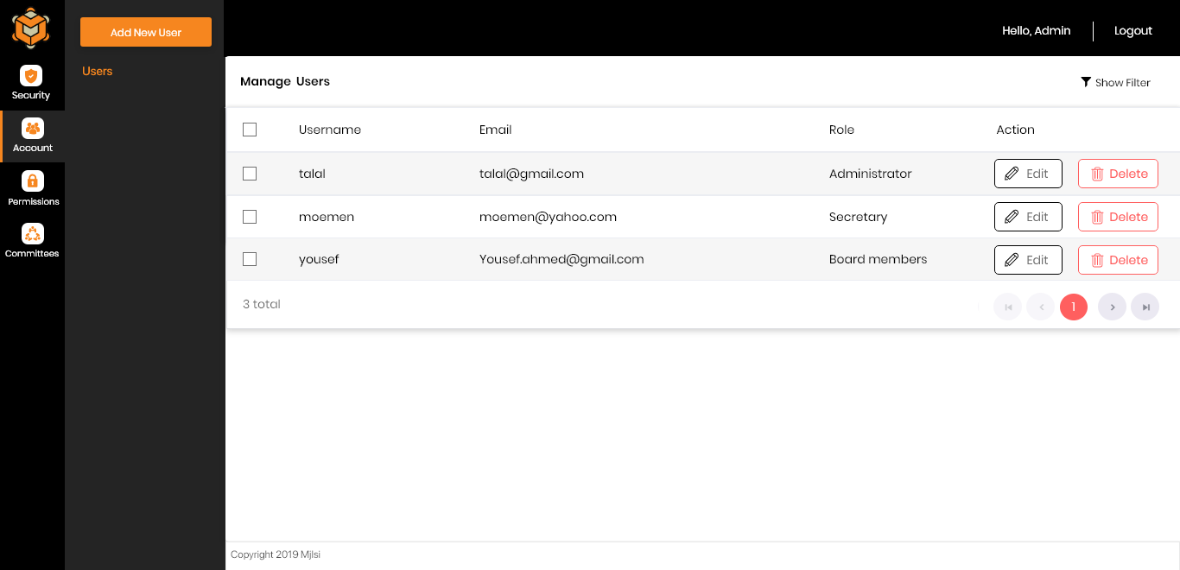

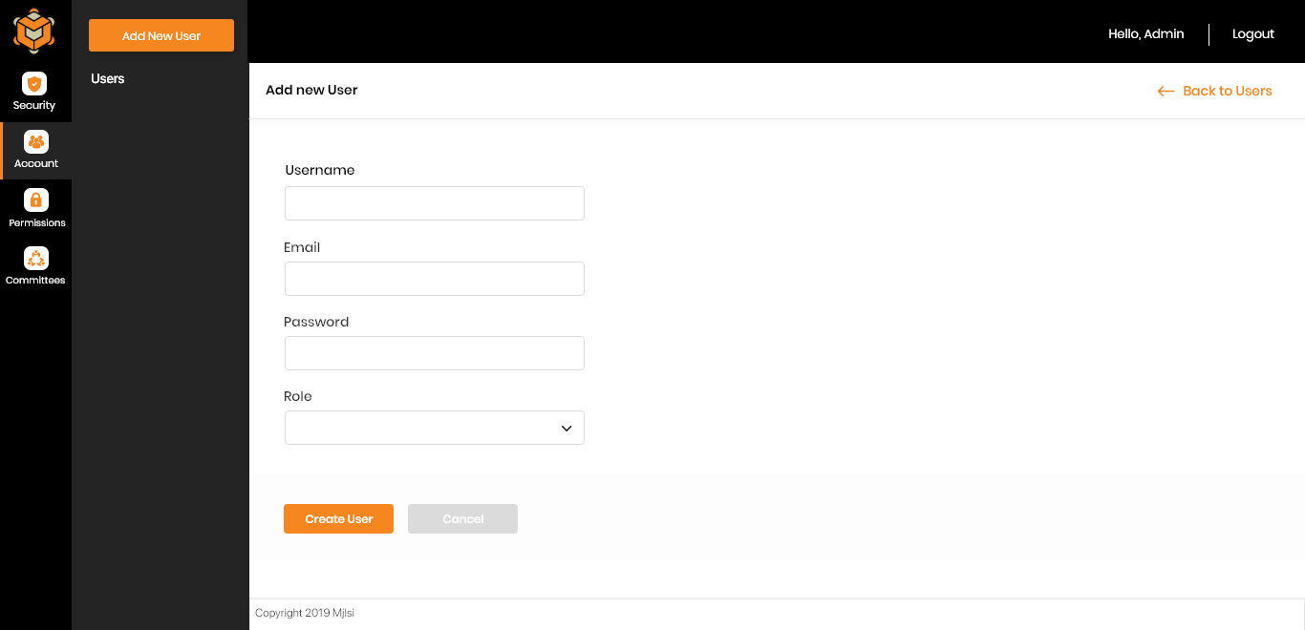

## Committees

Committees are a convenient way to manage access rights across different sets of users, e.g. finance subcommittee or membership committee.

### Committees Listing

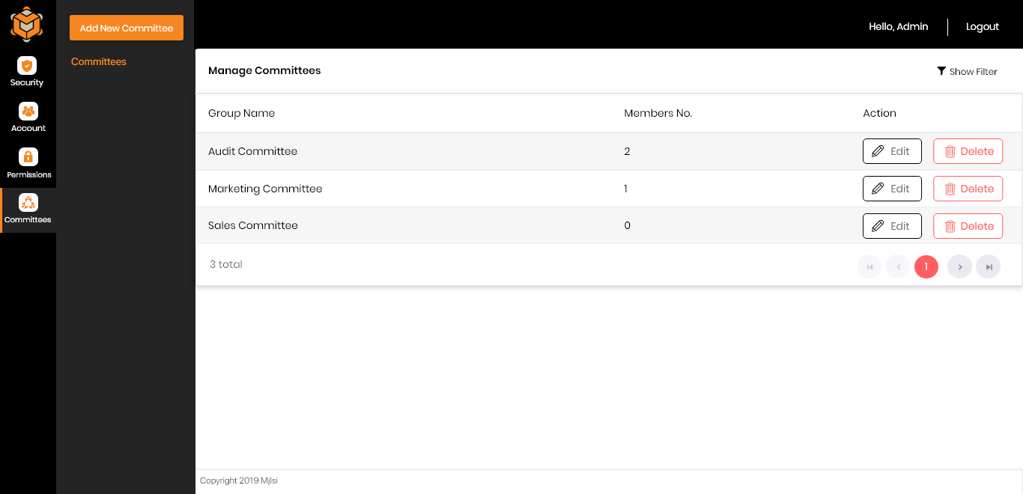

### Add a New Committee

1. Click System Admin.

2. Go to Committees tab.

3. Click Add Committee.

4. Enter the Committee Name.

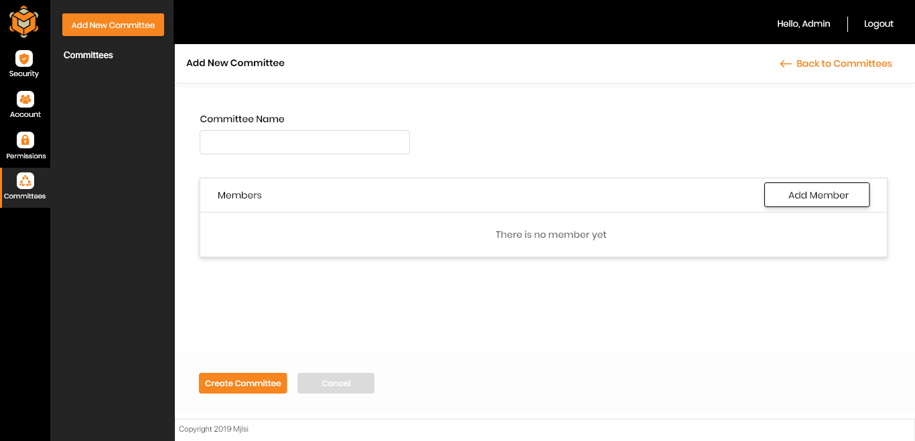

5. Click Add Members Button.

6. Members Modal will appear.

7. Tick the checkbox beside the users you want to add to the group.

8. Click Add

